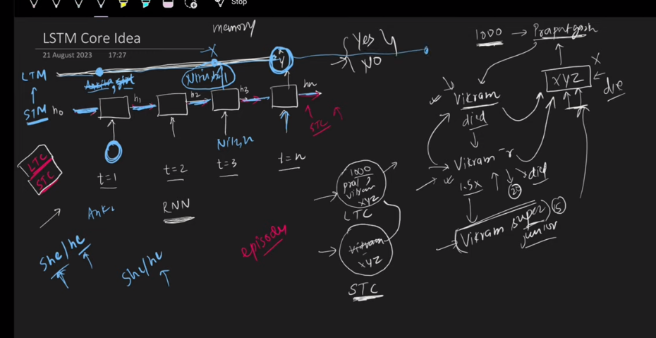
LSTM m naik long term path hota hai or aik short term.
Data short term path mn enter hota hai, agar hamein lgta hai ky ye data important hai to ham usy long term mn bhej dety hain, or wo tab tk rehta hai jab tk ham usy long term path sy nhi hata dety. Agy move krny ky bd agar short term path ko ye realize ho jata hai ky pichla data or word important nhi hai to wo usay long term path sy hata deta hai.
Example ky liye Vikram wali story refer kr lo.

LSTM architecture:
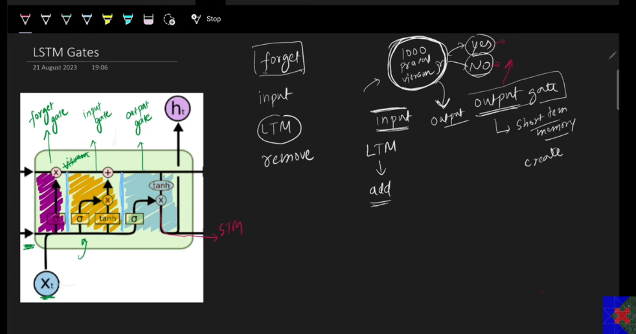
LSTM architecture has 3 gates:
- Forget Gate: ye btata hai ky ye word long term path mn sy nikal do
- Input gate: Ye btata hai ky ye word ya info long term path mn bhej do
- Output gate: Jo data or info long term path mn hai or jo current input hai uski base pr decision do ky kahani achi thi ya buri. Or output gate jo output dy rha hai wo agly stage ky liye short term memory hai

Summary:
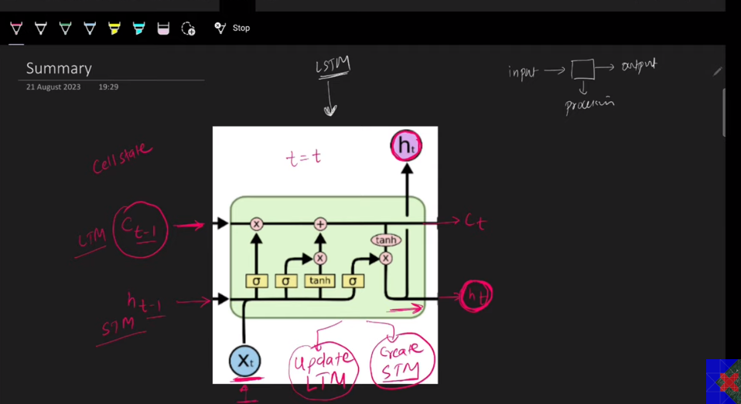

In LSTM:
Input:
We give three things in input:
- Last stage Long term memory
- Last stage Short Memory
- Input data

What happens in the architecture:
- Update Long term memory
- Create short term memory

Output:
- Updated Long term memory
- Short term memory

Blog link:
https://colah.github.io/posts/2015-08-Understanding-LSTMs/

LSTM mn hoty hain 3 gates, forget gate cell state mtlb ky Long term memory mn sy info or data remove krta hai. Input gate data ya info add krti hai Long Term Memory mn. Ab ye do gates mil kr update krty hain long term memory ko. Jo output gate hain na wo sirf hidden state calculate krta hai for next stage.

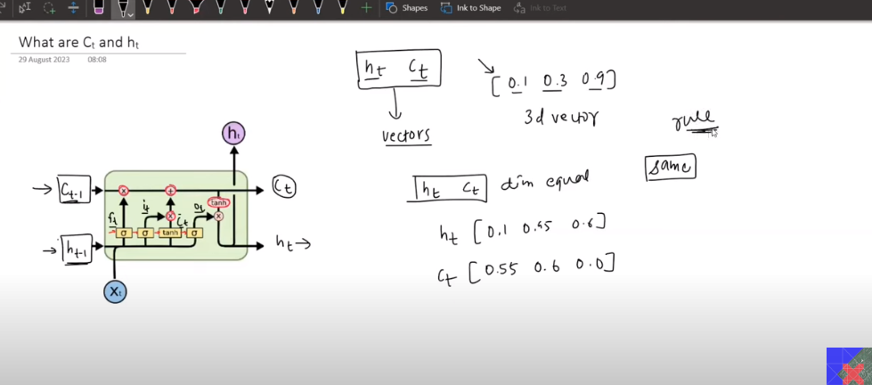

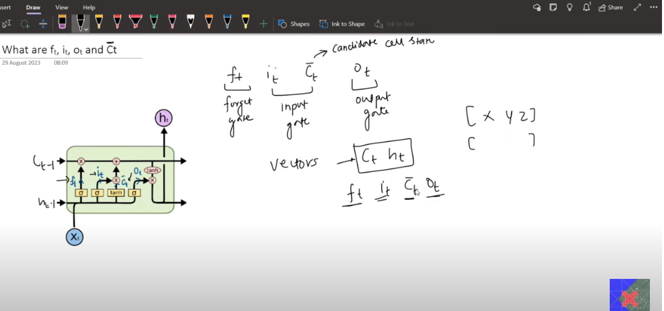

Ft, it, Ct, Ot inki dimensions same hotin hain hamesha.
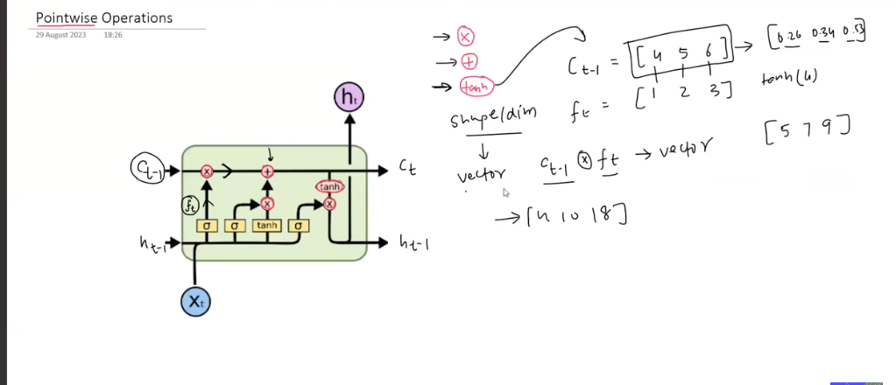

How to improve model performance?
- More data
- Hyperparameter tuning
- Advance architecture (stacked LSTM, bidirectional LSTM, Transformers)

